WEEK 5 – COMPREHENSIVE DATA SCIENCE PROJECT REPORT
Titanic Survival Analysis and Prediction

Internship: Virtual Data Science with Python Apprentice Intern
Project Domain: Data Science / Predictive Analytics
Dataset: Titanic Passenger Dataset
Tools: Python, Jupyter Notebook, Pandas, NumPy, Matplotlib, Seaborn, SciPy, Scikit-learn

End-to-End Project: Data Preparation → EDA → Statistical Analysis → Machine Learning → Recommendations

1. Executive Summary
This report presents an end-to-end data science analysis of the Titanic passenger dataset. The objective was to understand the factors associated with passenger survival and demonstrate how data science techniques can transform raw data into meaningful insights and predictive results. The work was completed progressively across five internship weeks, covering data acquisition and cleaning, exploratory data analysis, advanced visualization and storytelling, statistical hypothesis testing, machine learning, and final strategic interpretation.
For the integrated Week 5 analysis, the original Titanic dataset contained 891 passengers and 15 variables. The overall survival rate was 38.38%. Exploratory analysis showed strong differences in survival by gender and passenger class. Female passengers had substantially higher survival rates than male passengers, and first-class passengers generally had better survival outcomes than third-class passengers.
A Chi-Square test of independence produced a statistic of 260.717 and a p-value of approximately 1.20 × 10⁻⁵⁸. With a Cramér's V of 0.5409, the analysis provided strong evidence of a substantial association between gender and survival. A Logistic Regression model was then developed using passenger class, gender, age, family-related variables, fare, and embarkation information. The model achieved 80.45% accuracy and an ROC-AUC of 84.36%.

2. Introduction
The Titanic dataset is a widely used educational dataset containing passenger-level information from the RMS Titanic. It includes demographic, socioeconomic, family, travel, and survival information. It is suitable for demonstrating a complete data science workflow because it contains both numerical and categorical variables and a binary outcome.
The purpose of this project was not only to build a prediction model but also to understand the data before modelling. The project therefore combines descriptive statistics, visualization, statistical inference, and machine learning.

Project Objectives
- Acquire and understand a publicly available dataset.
- Identify missing values, duplicates, and data-quality issues.
- Perform exploratory data analysis using Python.
- Develop visualizations that communicate important patterns.
- Test a meaningful hypothesis using statistical analysis.
- Develop and evaluate a Logistic Regression classification model.
- Translate analytical findings into recommendations and future improvements.

3. Dataset Description
The Titanic dataset was accessed programmatically using the Seaborn Python library. No manual dataset download was required for the analysis; the dataset was loaded directly into the Jupyter notebook.
Variable | Description
survived | Survival status: 0 = did not survive, 1 = survived
pclass | Passenger class
sex | Passenger gender
age | Passenger age
sibsp | Number of siblings/spouses aboard
parch | Number of parents/children aboard
fare | Passenger fare
embarked | Port of embarkation
class | Passenger class as a category
who | Passenger category
adult_male | Whether the passenger was an adult male
deck | Deck information
embark_town | Embarkation town
alive | Survival represented as yes/no
alone | Whether the passenger travelled alone

4. Methodology
The project followed the following end-to-end workflow:
Data Acquisition → Data Cleaning → EDA → Visualization → Statistical Testing → Machine Learning → Evaluation → Recommendations

4.1 Data Acquisition
The dataset was loaded using Seaborn. This approach provided a reproducible method of acquiring the public dataset within the Python environment.
Code: df = sns.load_dataset("titanic")

4.2 Data Cleaning and Preprocessing
The dataset was inspected for missing values and duplicates. In the original Week 1 working dataset, four duplicate rows were identified. Missing values were documented rather than silently ignored. Numerical variables such as age were handled with median imputation during the machine-learning pipeline because the median is less sensitive to extreme values. Categorical variables were handled using the most frequent category. Categorical predictors were converted into numerical form using One-Hot Encoding.
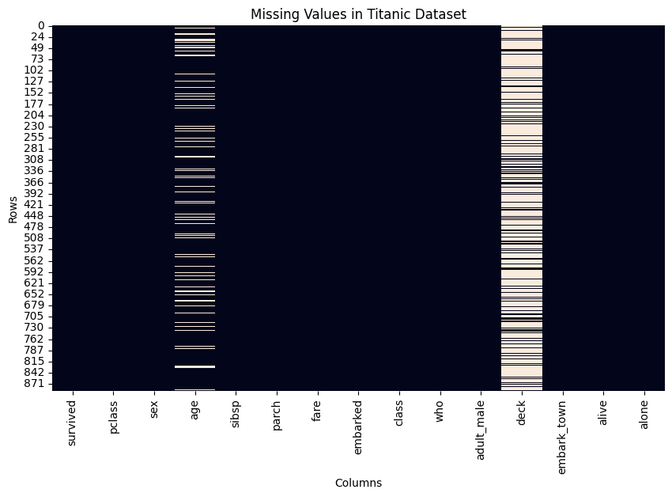
Figure 1. Missing Values in the Titanic Dataset

4.3 Exploratory Data Analysis
Summary statistics, frequency counts, group-based survival rates, distributions, and correlations were used to identify important patterns before modelling.

5. Exploratory Data Analysis

5.1 Overall Survival
The integrated dataset contained 549 passengers who did not survive and 342 passengers who survived. The overall survival rate was 38.38%, meaning that the majority of passengers in the dataset did not survive.
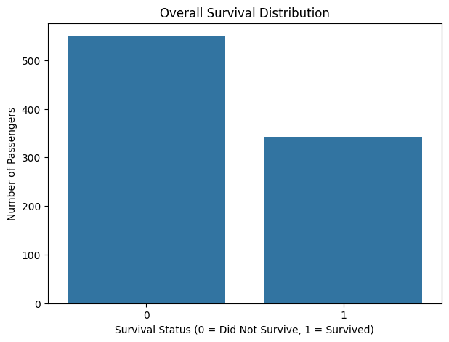
Figure 2. Overall Survival Distribution

5.2 Survival by Gender
Gender was one of the strongest patterns observed. In the Week 1 analysis, the survival rate was approximately 74.06% for females and 21.59% for males. This large difference motivated the statistical hypothesis test performed in Week 3.
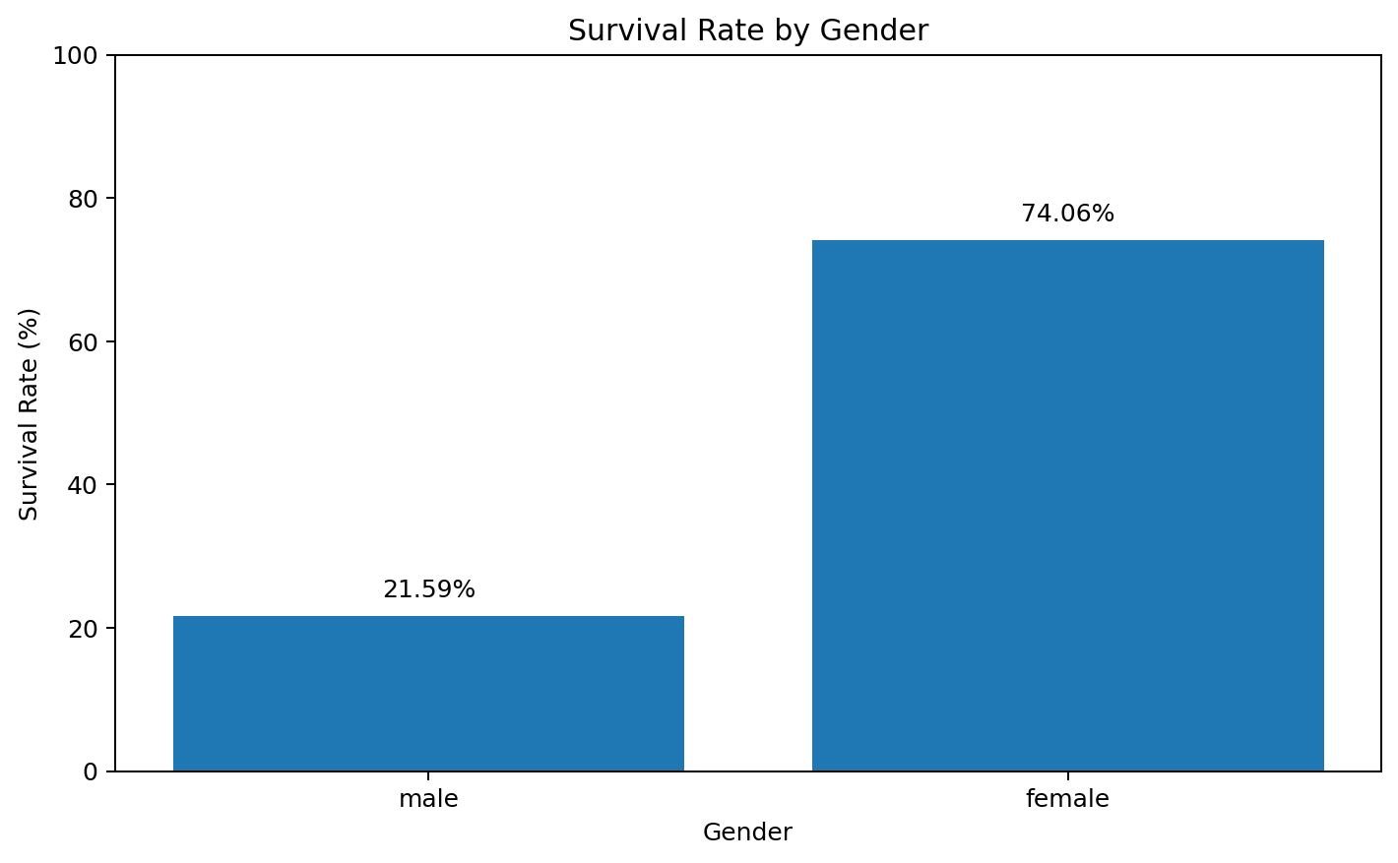
Figure 3. Survival Rate by Gender

5.3 Survival by Passenger Class
The Week 1 analysis showed survival rates of approximately 63.08% for first class, 50.91% for second class, and 25.68% for third class. This indicates that passenger class was strongly related to survival outcomes.
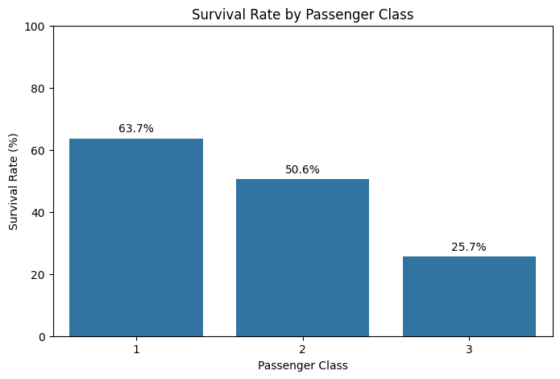
Figure 4. Survival Rate by Passenger Class

5.4 Age Distribution
The Week 1 age statistics showed a mean age of 29.65 years, a median of 28.25 years, a minimum of 0.42 years, and a maximum of 80 years. The distribution was concentrated around young and middle adulthood.
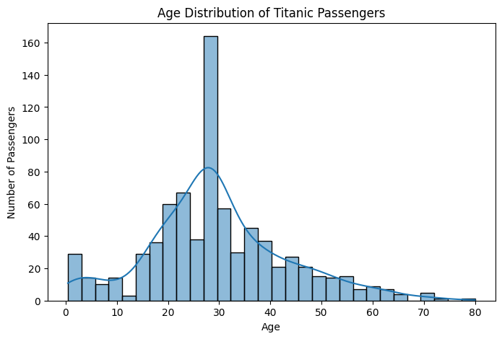
Figure 5. Age Distribution of Titanic Passengers

5.5 Fare Distribution
Fare was strongly right-skewed. The Week 1 analysis found a mean fare of 34.71 and a median fare of 15.90, with a maximum of 512.33. The difference between mean and median reflects a small number of passengers paying exceptionally high fares.
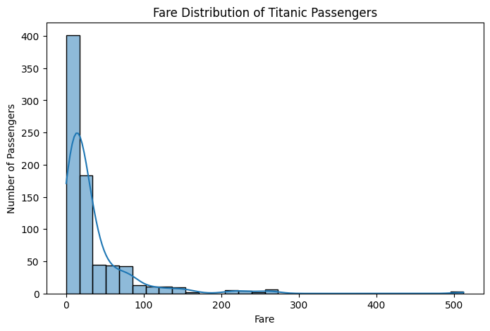
Figure 6. Fare Distribution of Titanic Passengers

5.6 Correlation Analysis
The numerical correlation matrix showed that fare had a positive correlation of approximately 0.25 with survival, while age had a small negative correlation of approximately -0.08 with survival. Sibling/spouse count and parent/child count had relatively weak direct correlations with survival.
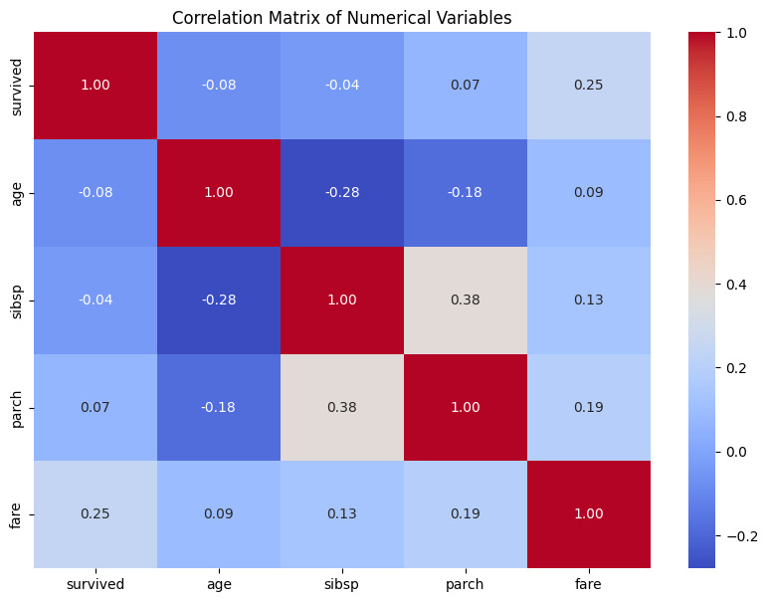
Figure 7. Correlation Matrix of Numerical Variables

6. Advanced Data Visualization and Storytelling
Week 2 extended the exploratory analysis by examining interactions between variables. These visualizations helped move from isolated statistics toward a more coherent data story.

6.1 Gender and Passenger Class
The interaction between gender and passenger class revealed particularly large differences in survival. Female passengers in first and second class had very high survival rates, while male passengers in second and third class had substantially lower survival rates.
Gender | Class | Survival Rate
Female | 1 | 96.77%
Female | 2 | 91.67%
Female | 3 | 47.24%
Male | 1 | 37.82%
Male | 2 | 18.48%
Male | 3 | 15.88%

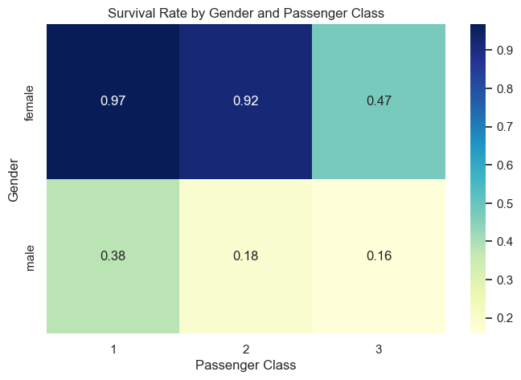
Figure 8. Survival Rate by Gender and Passenger Class

6.2 Age and Survival
The Week 2 analysis found that the average age of non-survivors was 30.50 years, compared with 28.33 years for survivors. The difference was comparatively small, suggesting that age alone was less informative than gender or class.
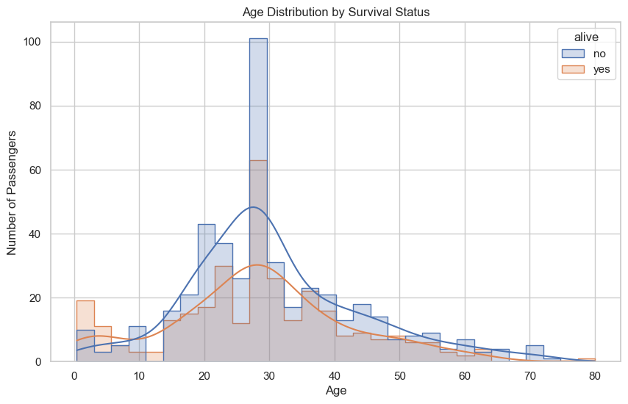
Figure 9. Age Distribution by Survival Status

6.3 Family Size
Family size showed varying survival rates. A family size of four had the highest observed survival rate at about 71.43%, while very large family groups had lower rates. Because some family-size categories contained relatively few observations, these results should be interpreted cautiously.

6.4 Age, Fare, and Survival
The scatter plot demonstrated that fare values were concentrated at lower levels, while a small number of high-fare observations appeared across different age groups. Survival outcomes were mixed, reinforcing the importance of considering several variables together.
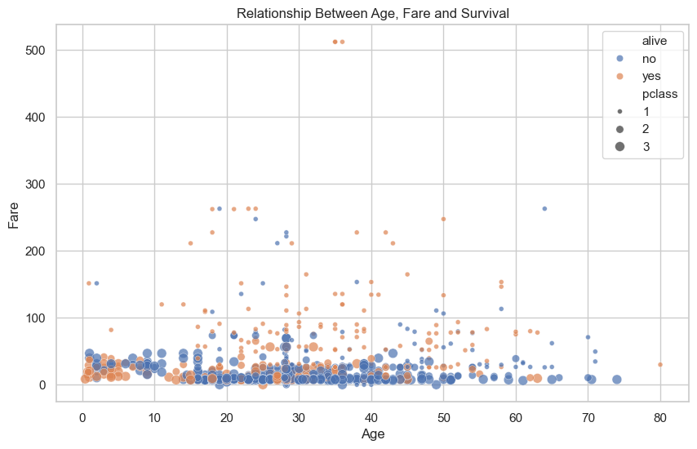
Figure 11. Relationship Between Age, Fare, and Survival

7. Statistical Hypothesis Testing

7.1 Research Question
Is passenger gender significantly associated with survival?

7.2 Hypotheses
Null Hypothesis (H₀): There is no significant association between passenger gender and survival.
Alternative Hypothesis (H₁): There is a significant association between passenger gender and survival.

7.3 Chi-Square Test Results
Measure | Result
Chi-Square Statistic | 260.717
P-value | 1.1973570627755645 × 10⁻⁵⁸
Degrees of Freedom | 1
Cramér's V | 0.5409
Minimum Expected Frequency | 120.54

The minimum expected frequency was 120.54, so the expected-frequency condition for the Chi-Square test was satisfied.

7.4 Interpretation
The p-value is far below the 0.05 significance level. Therefore, the null hypothesis is rejected. There is strong statistical evidence of an association between passenger gender and survival. Cramér's V of 0.5409 indicates a substantial association. The statistical result supports the strong pattern observed in the visual analysis.

8. Machine Learning Model

8.1 Model Selection
Logistic Regression was selected because the target variable, survived, is binary. The model provides a simple, interpretable baseline for classification and is appropriate for demonstrating a supervised learning workflow.
Selected predictors: pclass, sex, age, sibsp, parch, fare, and embarked.
The data was split into 80% training data and 20% testing data using stratification. Numerical missing values were imputed using the median, categorical missing values using the most frequent category, and categorical variables were one-hot encoded.

8.2 Model Performance
Metric | Score
Accuracy | 80.45%
Precision | 79.31%
Recall | 66.67%
F1 Score | 72.44%
ROC-AUC | 84.36%

The model achieved 80.45% accuracy, meaning it correctly classified approximately four out of every five test observations. The ROC-AUC of 0.8436 indicates good discrimination between survivors and non-survivors. The recall of 66.67% also shows that some actual survivors were classified as non-survivors.

8.3 Confusion Matrix
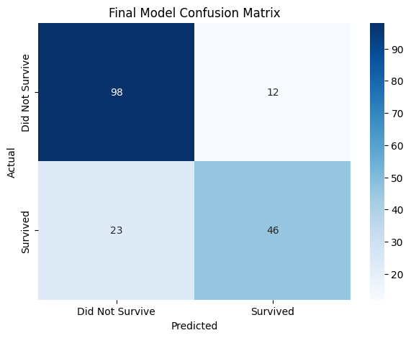
Figure 12. Final Logistic Regression Confusion Matrix

Actual / Predicted | Did Not Survive | Survived
Did Not Survive | 98 | 12
Survived | 23 | 46

The model correctly classified 98 non-survivors and 46 survivors. It incorrectly classified 12 non-survivors as survivors and 23 survivors as non-survivors.

8.4 ROC Curve
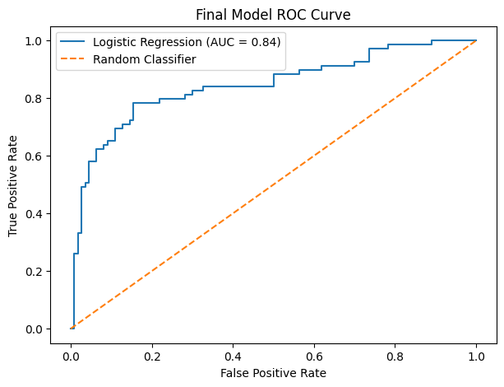
Figure 13. Final Logistic Regression ROC Curve (AUC = 0.8436)

The ROC curve lies substantially above the random-classifier reference line. The AUC of 0.8436 indicates that the model has useful predictive capability.

9. Key Findings
- The overall survival rate in the integrated dataset was 38.38%.
- Female passengers had substantially higher survival rates than male passengers.
- First-class passengers generally had higher survival rates than third-class passengers.
- The combination of gender and passenger class revealed especially large differences in survival.
- Survivors had a higher average fare (50.19) than non-survivors (24.03) in the Week 2 analysis.
- Survivors were slightly younger on average (28.33 years) than non-survivors (30.50 years).
- The Chi-Square test confirmed a statistically significant association between gender and survival.
- The Logistic Regression model achieved 80.45% accuracy and 84.36% ROC-AUC.

10. Strategic Recommendations
- Analyze multiple variables together rather than relying on a single predictor.
- Investigate interactions between gender, passenger class, age, fare, and family characteristics.
- Use feature engineering, such as age groups and family-size categories, to capture meaningful patterns.
- Compare Logistic Regression with Decision Tree, Random Forest, and Gradient Boosting models.
- Use cross-validation and hyperparameter tuning to obtain more robust and potentially improved performance.
- Evaluate models using several metrics rather than accuracy alone, especially when different types of errors have different importance.

11. Business and Research Impact
Although the Titanic dataset is historical, the project demonstrates a general data science workflow that can be applied to many real-world datasets. The same approach can be used in business, research, operations, and other domains where analysts need to transform raw information into evidence-based insights.
From a research perspective, the project demonstrates why visual patterns should be supported by statistical tests. The Chi-Square test provided strong evidence that the observed gender-survival relationship was not likely to be due to random variation in this dataset.
From a modelling perspective, the project shows the importance of preprocessing, feature selection, model evaluation, and error analysis. The Logistic Regression model produced useful predictive performance, while its recall also highlighted that accuracy alone does not tell the complete story.

12. Limitations
- The Titanic dataset is relatively small compared with many modern real-world datasets.
- The dataset contains missing values, particularly in age and deck information.
- The data represents a historical event and contains historical and social biases.
- The findings should not be generalized directly to modern transportation or emergency situations.
- Logistic Regression may not capture complex nonlinear relationships between variables.
- The final model used a single train-test split rather than repeated cross-validation.
- Some family-size categories contain relatively few observations.
- Statistical association does not establish causation.

13. Future Improvements
- Perform k-fold cross-validation for more reliable model evaluation.
- Compare Logistic Regression with Decision Tree, Random Forest, and Gradient Boosting.
- Apply hyperparameter tuning.
- Engineer features such as family size, age groups, and combined passenger categories.
- Investigate interactions between important predictors.
- Use feature-importance and explainability techniques.
- Build an interactive dashboard to communicate results to non-technical audiences.

14. Conclusion
This project successfully demonstrated a complete data science workflow using the Titanic dataset. The analysis progressed from data acquisition and cleaning to exploratory analysis, advanced visualization, statistical hypothesis testing, machine learning, and strategic interpretation.
The exploratory analysis identified major differences in survival according to gender and passenger class. Female passengers generally had much higher survival rates than male passengers, while first-class passengers had better survival outcomes than third-class passengers.
The Chi-Square hypothesis test produced a p-value of approximately 1.20 × 10⁻⁵⁸ and a Cramér's V of 0.5409, providing strong statistical evidence of a substantial association between gender and survival.
The final Logistic Regression model achieved 80.45% accuracy, 79.31% precision, 66.67% recall, 72.44% F1-score, and 84.36% ROC-AUC. These results demonstrate that passenger characteristics contain useful information for predicting survival.
Overall, the project demonstrates how data cleaning, visualization, statistical analysis, and machine learning can be combined to transform raw data into meaningful insights and predictive results. It also establishes a foundation for future work involving advanced models, feature engineering, cross-validation, and explainable AI.

15. Technologies Used
- Python
- Jupyter Notebook
- Pandas
- NumPy
- Matplotlib
- Seaborn
- SciPy
- Scikit-learn
- GitHub
- Microsoft Word

16. Appendix – Important Code Snippets
Dataset loading
df = sns.load_dataset("titanic")
Missing-value analysis
df.isnull().sum()
Survival counts
df["survived"].value_counts()
Gender/class analysis
df.groupby(["sex", "pclass"])["survived"].mean()
Chi-Square test
contingency_table = pd.crosstab(df["sex"], df["survived"])
Model training
model.fit(X_train, y_train)
Prediction
y_pred = model.predict(X_test)
Probability prediction
y_probability = model.predict_proba(X_test)[:, 1]

